Exercise 2-2 Image compare

Jirayu Petchhan, D10907801

Data directory

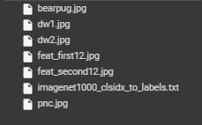

I take one and two class images respectively for testing (g1.jpg, g2.jpg)

|  |  |
| --- | --- |
| C:\Users\e_user\AppData\Local\Microsoft\Windows\INetCache\Content.Word\dw1.jpg | C:\Users\e_user\Downloads\2-2 Feature Compare\dw2.jpg |
| Dw1.jpg | Dw1.jpg |
| My image usage | |
|  | C:\Users\e_user\AppData\Local\Microsoft\Windows\INetCache\Content.Word\bearpug.jpg |
| Pnc.jpg | Bearpug.jpg |

Model trained download usage (VGG16)

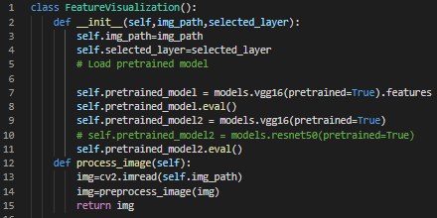

Prediction define function

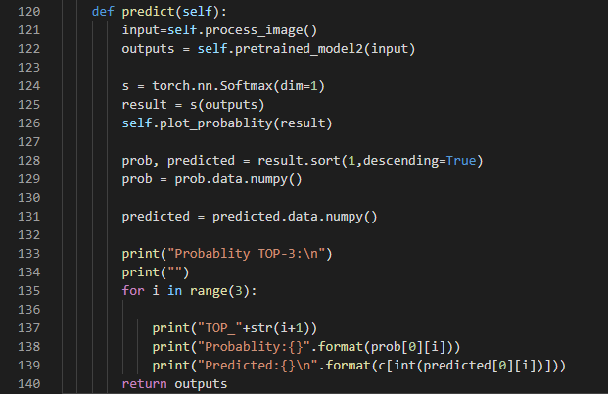

Get class and compare feature map between two classes at the same defined layer (e.g. given layer 12) and compare with two methods i.e. cosine and Euclidean distance.

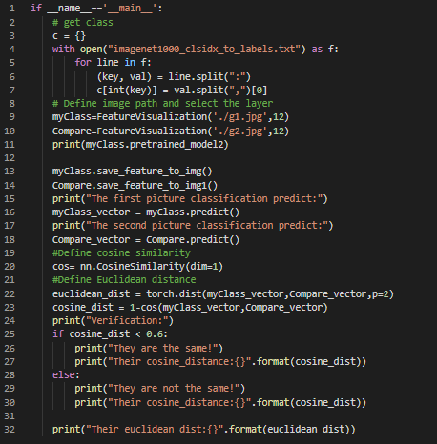

Model printed (VGG16)

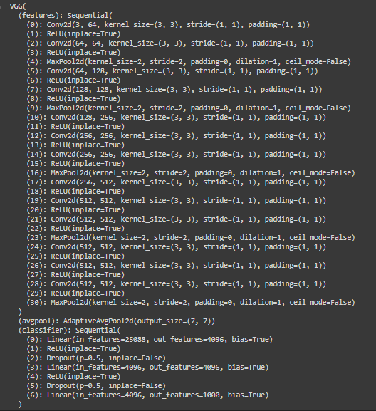

**Compare image (dw1 and dw2.jpg)**

Probability of class prediction of dw1.jpg and top-3 of prediction of dw1.jpg

Feature map of dw1.jpg



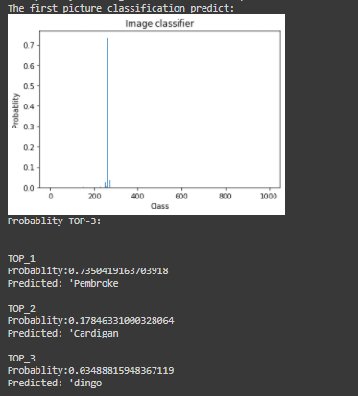

Probability of class prediction of dw2.jpg and top-3 of prediction of dw2.jpg

Feature map of dw2.jpg

C:\Users\e_user\Downloads\2-2 Feature Compare\11_2.jfif

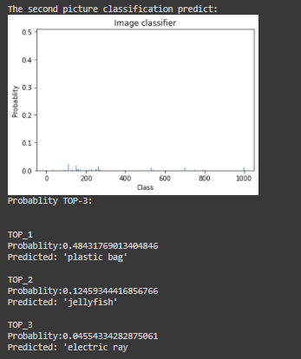

Cosine distance = 0.4809

Euclidean score = 88.5488

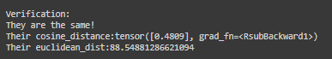

**Compare image (pnc and bearpug.jpg)**

Probability of class prediction of pnc.jpg and top-3 of prediction of pnc.jpg

Feature map of pnc.jpg



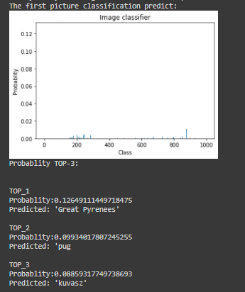

Probability of class prediction of bearpug.jpg and top-3 of prediction of bearpug.jpg

Feature map of bearpug.jpg



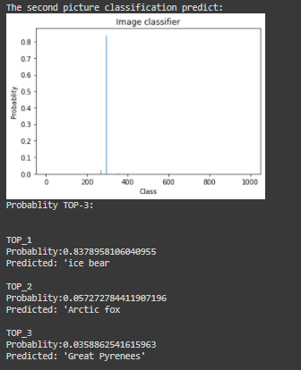

Cosine distance = 0.3819

Euclidean score = 86.0470886

